The Parish of St Andrew
Orford with Longford

Order of Service
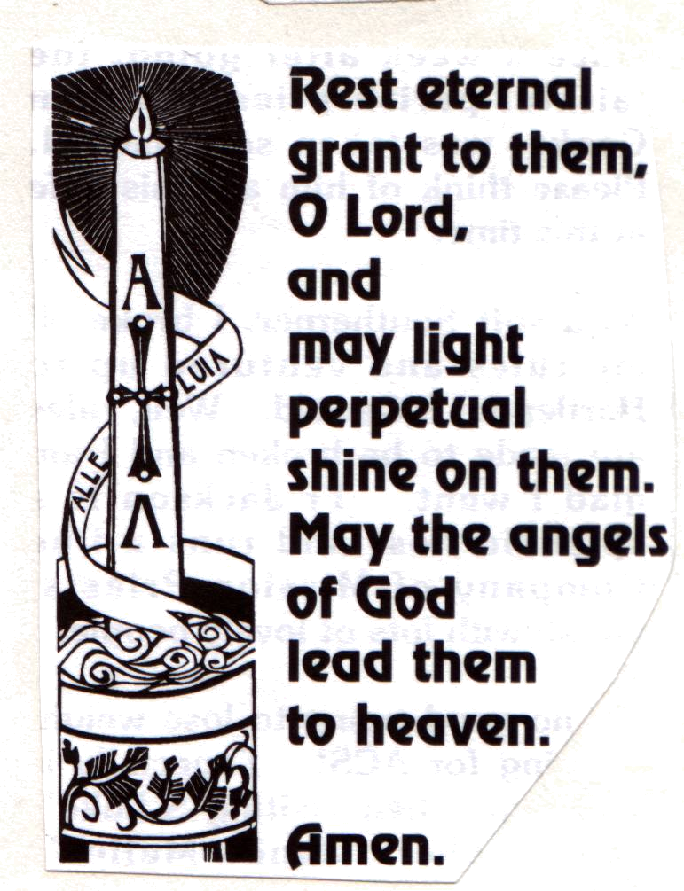

Frederick Broadhurst
1933 -2001

Please STAND as the funeral procession enters the church. Please sit once the family are seated. When everyone is in their place:

Opening hymn: (seated) ‘I the Lord of sea and sky’

1 | I, the Lord of sea and sky,  I have heard my people cry.  All who dwell in dark and sin  my hand will save.  I who made the stars of night,  I will make their darkness bright.  Who will bear my light to them?  Whom shall I send? | 2 | I the Lord of snow and rain,  I have borne my people’s pain.  I have wept for love of them.  They turn away.  I will break their hearts of stone,  give them hearts for love alone.  I will speak my word to them.  Whom shall I send?
 | Here I am, Lord. Is it I Lord?  I have heard you calling in the night.  I will go Lord, if you lead me.  I will hold your people in my heart. | 3 | I, the Lord of wind and flame,  I will tend the poor and lame.  I will set a feast for them.  My hand will save.  Finest bread I will provide  till their hearts are satisfied.  I will give my life to them.  Whom shall I send?

Opening prayers from the grey booklet.

Hymn: The King of love my shepherd is,
whose goodness faileth never;
I nothing lack if I am his
and he is mine for ever.

Where streams of living water flow
my ransomed soul he leadeth,
and where the verdant pastures grow
with food celestial feedeth.

Perverse and foolish oft I strayed,
but yet in love he sought me,
and on his shoulder gently laid,
and home rejoicing brought me.

In death's dark vale I fear no ill
with thee dear Lord beside me;
thy rod and staff my comfort still,
thy cross before to guide me.

Thou spread'st a table in my sight;
thy unction grace bestoweth;
and O what transport of delight
from thy pure chalice floweth!

And so through all the length of days
thy goodness faileth never:
good Shepherd, may I sing thy praise
within thy house for ever.

Please sit:

A reading from the Letter to the Romans chapter 5, verses 1- 5,
read by Shirley Anson, one of Fred’s nieces:

Therefore, since we have been justified through faith, we have peace with God through our Lord Jesus Christ, through whom we have gained access by faith into this grace in which we now stand. And we rejoice in the hope of the glory of God. Not only so, but we also rejoice in our sufferings, because we know that suffering produces perseverance; perseverance, character; and character, hope. And hope does not disappoint us, because God has poured out his love into our hearts by the Holy Spirit, whom he has given us.

This is the word of the Lord. Thanks be to God.

The Address.

Hymn: I watch the sunrise lighting the sky,
casting its shadow near;
and on this morning, bright though it be,
I feel those shadows near me.

But you are always close to me, following all my ways.
May I be always close to you, following all your ways, Lord.
I watch the sunlight shine through the clouds
warming the earth below;
and at the mid-day life seems to say:
"I feel your brightness near me."
But you are always close to me ...

I watch the sunset fading away
lighting the clouds with sleep;
and as the evening closes its eyes
I feel your presence near me.
But you are always close to me ...

I watch the moonlight guarding the night,
waiting till morning comes.
The air is silent, earth is at rest -
only your peace is near me.
But you are always close to me ...

The Prayers: on page 2 of the grey booklet

Hymn: Abide with me; fast falls the eventide:
the darkness deepens; Lord, with me abide:
when other helpers fail, and comforts flee,
help of the helpless, O abide with me.

Swift to its close ebbs out life's little day;
earth's joys grow dim, its glories pass away;
change and decay in all around I see:
O thou who changest not, abide with me.

Hold thou thy cross before my closing eyes;
shine through the gloom, and point me to the skies:
heaven's morning breaks, and earth's vain shadows flee;
in life, in death, O Lord, abide with me.

The Farewell and Commendation [please remain standing]

The Service concludes at Walton Lea Crematorium

Frederick Broadhurst
1933 - 2001

Reading: Romans 5, verses 1-5

Therefore, since we have been justified through faith, we have peace with God through our Lord Jesus Christ, through whom we have gained access by faith into this grace in which we now stand. And we rejoice in the hope of the glory of God. Not only so, but we also rejoice in our sufferings, because we know that suffering produces perseverance; perseverance, character; and character, hope. And hope does not disappoint us, because God has poured out his love into our hearts by the Holy Spirit, whom he has given us.

This is the word of the Lord. Thanks be to God.

